Telanagana State Industrial Project Approval & Self Certification System (TS-iPASS)

Entrepreneur Login Incentive Module
USER MANUAL
Prepared by



FRUX Software Solutions Pvt. Ltd.,
Flat 401, SVP Residency, Lane: 5,
Balaji Nagar, Nizampet, Hyderabad,
Telangana-500090.

Incentives Registration / View Eligible Incentives:

To encourage Entrepreneurs to set up industries, Government of Telangana is giving many incentives depending upon Entrepreneurs eligibility. Before applying for an incentives any entrepreneur can check their eligibility for the incentives can be done using following steps:

Open https://ipass.telangana.gov.in/ link in google chrome

On right side of the page you will find one option called Incentives

Click on Incentives option

Below screen will be displayed

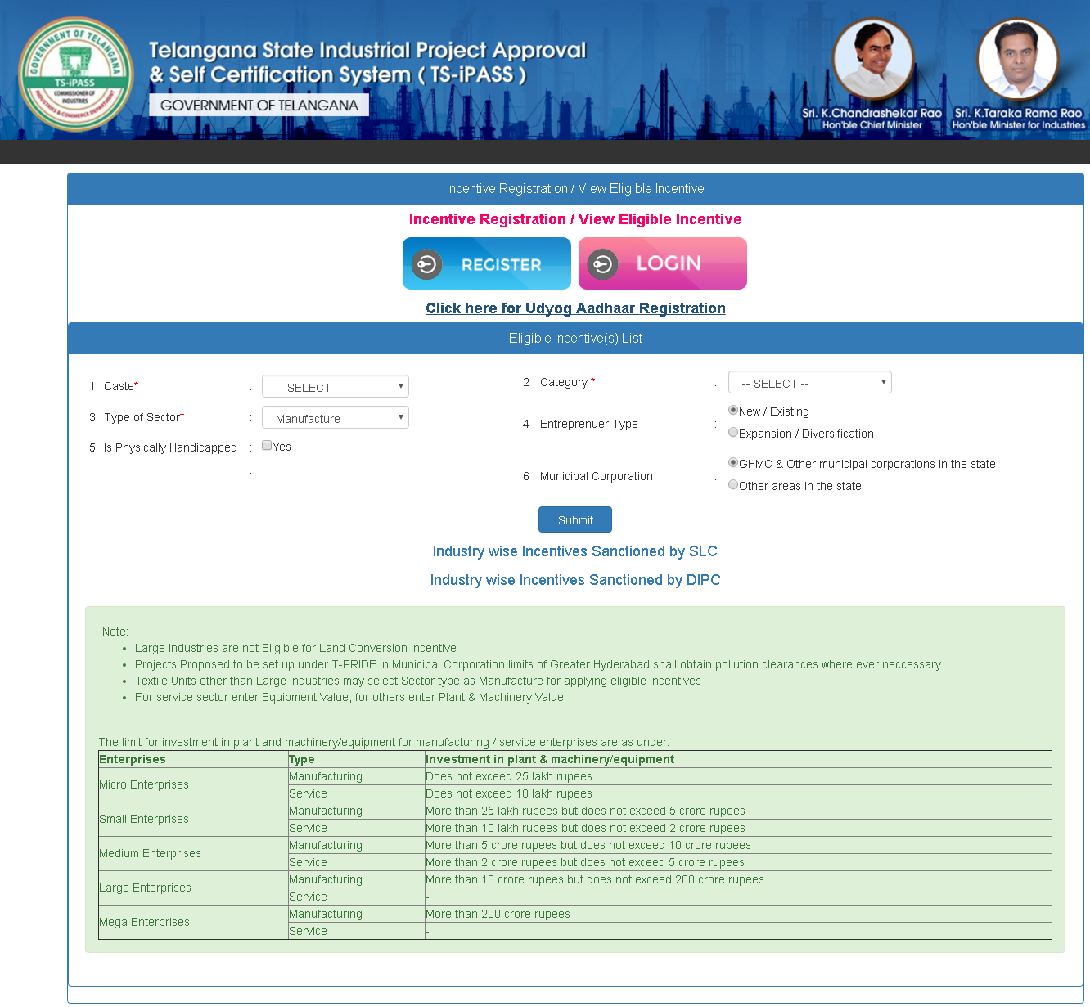
By giving the above details like Caste of the Entrepreneur, Type of Sector, Physically Handicapped, Category, Entrepreneur type, Municipal corporation and clicking on submit you will get the incentives details for which you are eligible for. Please see the below screen for your better understand.

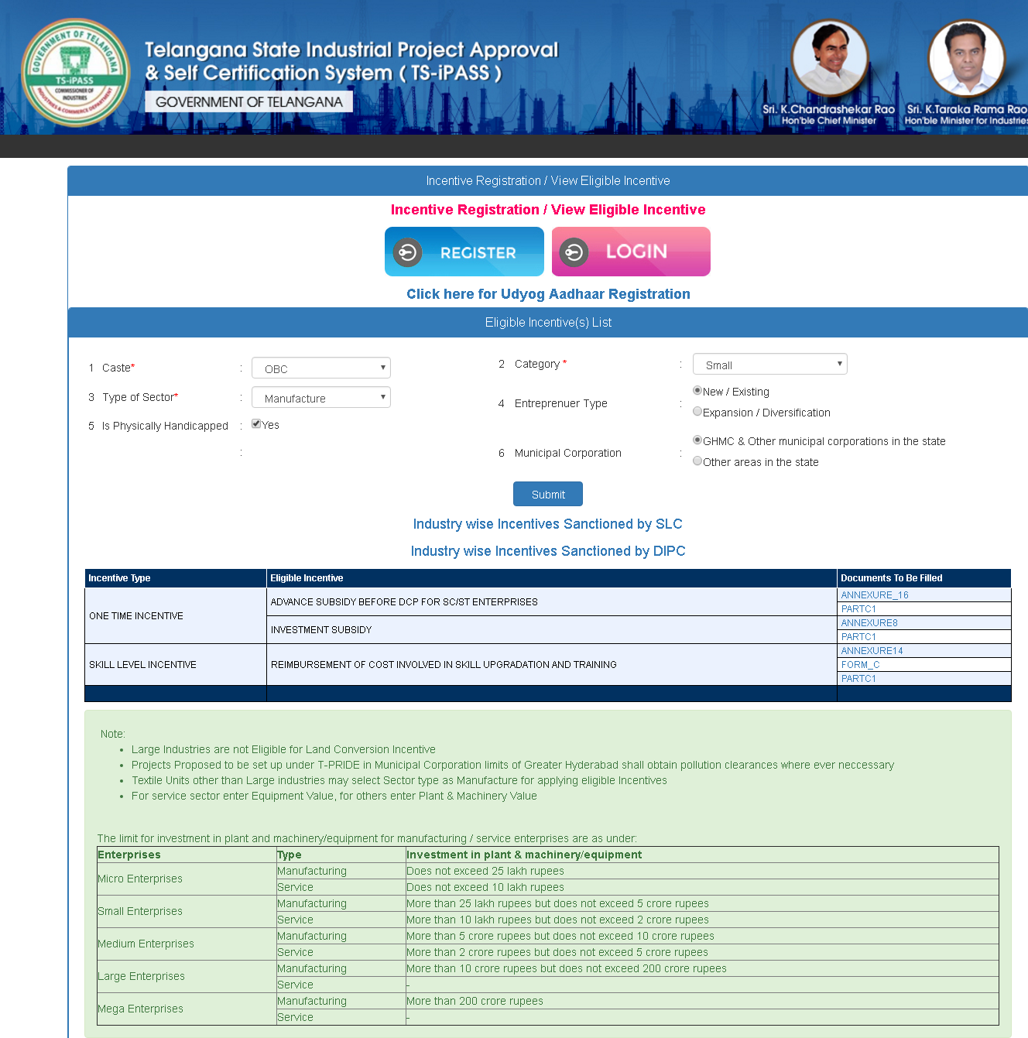

Login Screen:

Login Screen
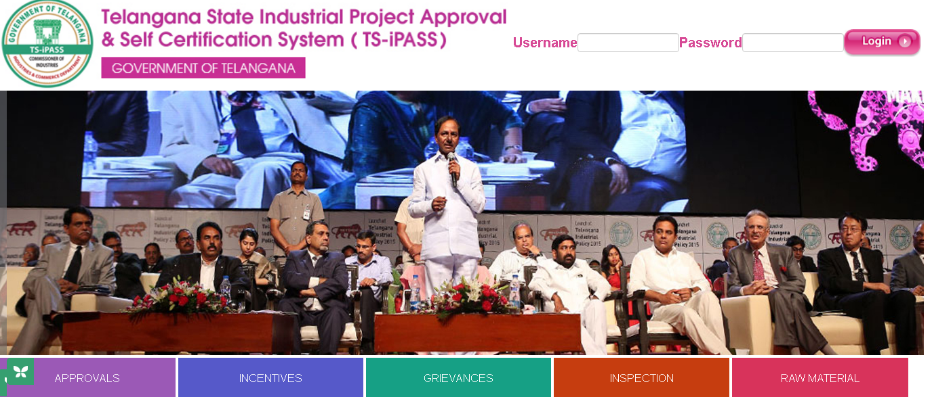
Screen Description:

This screen is used to Authenticate and Authorize for accessing and using different features and functionalities in Telanagana State Industrial Project Approval & Self Certification System (TS-iPASS). You can Login to the application by providing your User Credentials like User Name and Password.
Sl. No | Input Type | Description | Mandatory (Yes/No/NA)
1 | User Name | Enter the User name | Yes
2 | Password | Enter the Password | Yes
3 | Login | Click on Login button to log into the MIS | Yes
4 | Cancel | Click on Cancel to clear the columns in the Login Page | NA

Incentives:

Incentives Menu
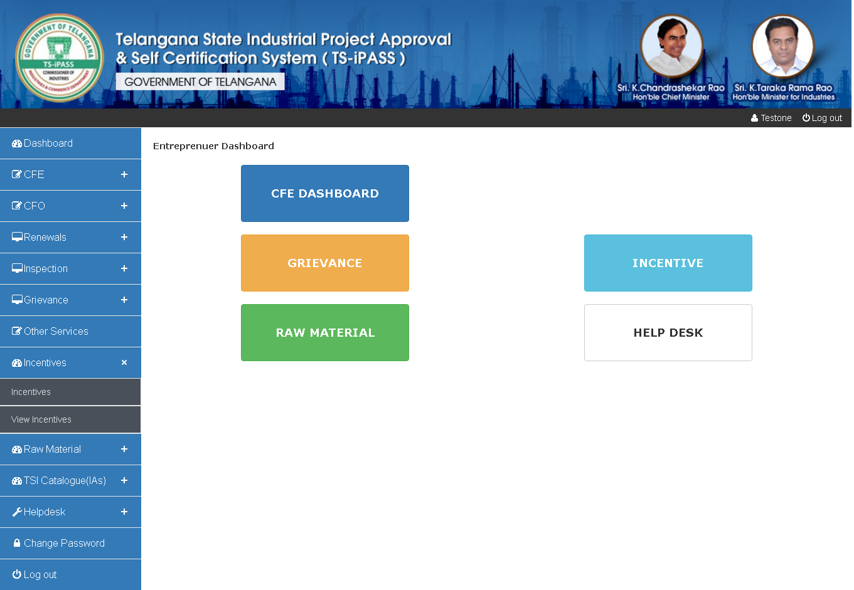
Screen Description:

When you click on Incentives under Incentives option on left side of the menu then below screen will be displayed:

Incentives:

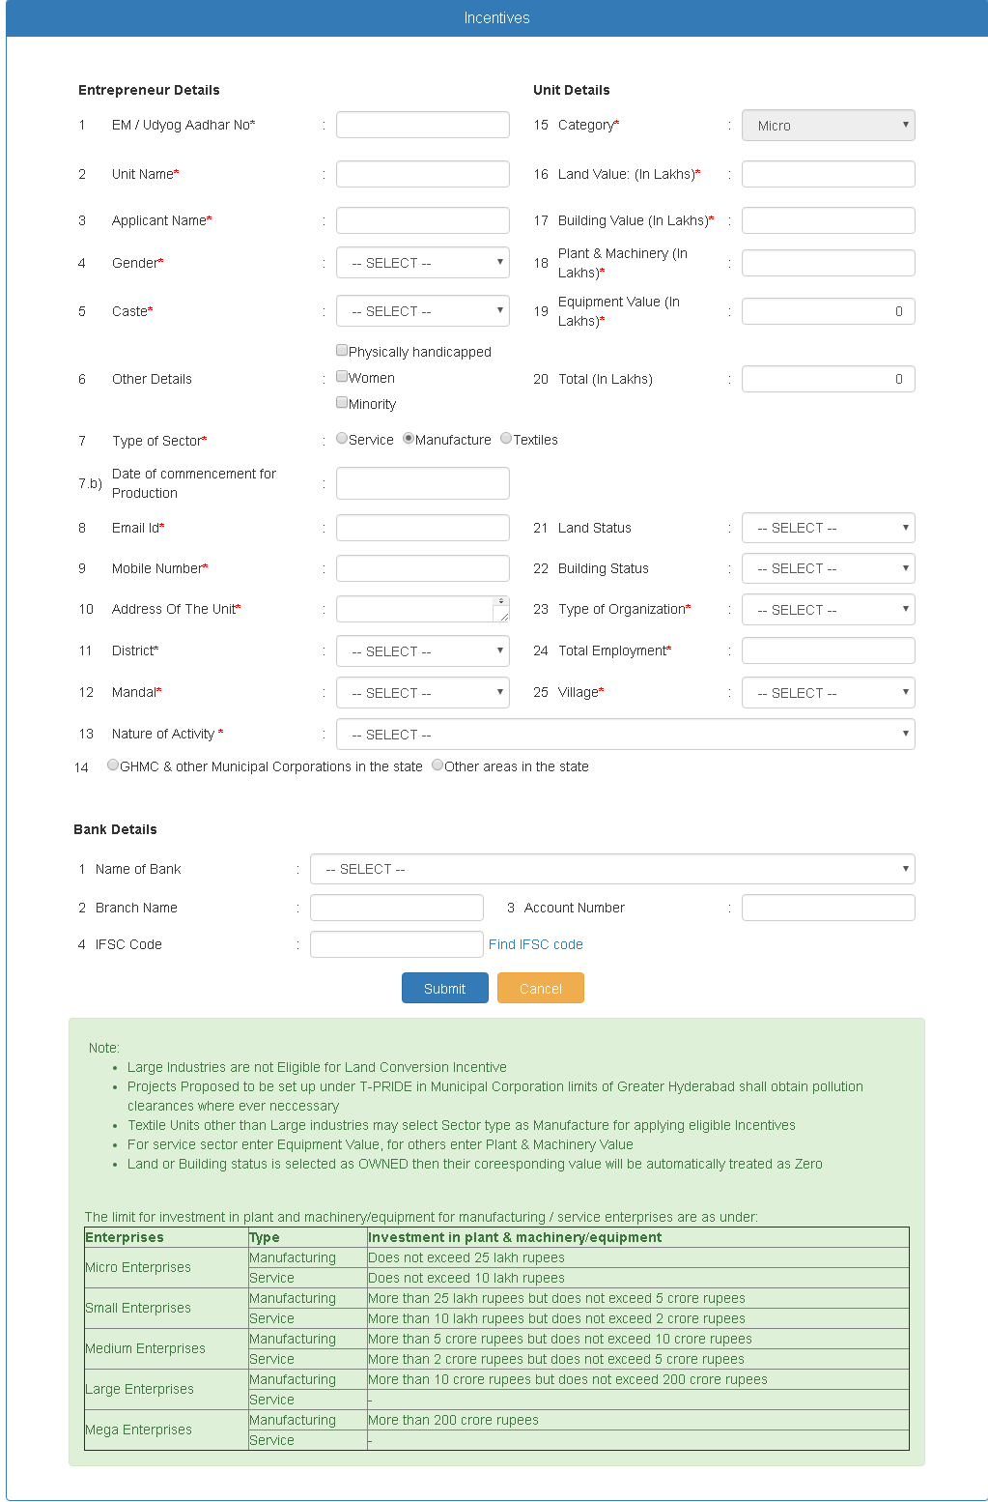
Screen Description: This screen is used to apply for Incentives
Sl. No | Input Type | Description in English | Mandatory (Yes/No/NA)
1 | EMI / Udyog Aadhaar No | Enter the EMI / Udyog Aadhaar number of the entrepreneur | Yes
2 | Unit Name | Enter the Unit Name | Yes
3 | Applicant Name | Enter the Applicant Name | Yes
4 | Gender | Select the Gender of the applicant from dropdown i.e. Male / Female | Yes
5 | Caste | Select the Caste of the applicant from General / OBC / SC / ST / Others | Yes
6 | Other Details | Select the Other details suitable to the entrepreneurs like Physically Handicapped / Women / Minority | Yes
7 | Type of Sector | Select the type of the Industry i.e. Service / Manufacture / Textile | Yes
7 | Type of Sector | If you select Service sector, MIS will ask you for that is the services belongs to Transport allied activities or Other Services sector
8 | Date of commencement for Production | Enter the date of commencement for Production | Yes
9 | Email ID | Enter the Email Id of the entrepreneur | Yes
10 | Mobile Number | Enter the Mobile number of the entrepreneur | Yes
11 | Address Of The Unit | Enter the address of the Unit | Yes
12 | District | Select the District of the entrepreneur | Yes
13 | Mandal | Select the Mandal of the entrepreneur | Yes
14 | Nature of Service Activity | Enter the Nature of Service Activity of the Unit | Yes
15 | Select the Appropriate option | Select the appropriate option is the unit falls under GHMC & Other Municipal Corporations in the state or Other areas in the State | Yes
16 | Category | Depending upon the Land, Building, Plant & Machinery and Equipment value category will come automatically | Yes
17 | Land Value | Enter the Land Value in Lacs | Yes
18 | Building Value | Enter the Building value in Lacs | Yes
19 | Plant & Machinery | Enter the Plant & Machinery value in Lacs | Yes
20 | Equipment Value | Enter the Equipment value in Lacs | Yes
21 | Total | Sum of total will be displayed automatically | Yes
22 | Land Status | Select the Land status from dropdown i.e. Leases / Rent / Owned | Yes
23 | Building Status | Select the appropriate Building status from dropdown i.e. Leased / Rent / Owned | Yes
24 | Type of Organization | Select the Type of Organization from the dropdown i.e. Proprietary / Partnership / Pvt Ltd / Public Limited / Co-Operative / LLP | Yes
25 | Total Employment | Enter the count of total employees being working in that unit | Yes
26 | Village | Select the Unit village from the dropdown | Yes
Bank Details:
27 | Name of the Bank | Select the name of the bank in which the unit has account | Yes
28 | Branch Name | Enter the name of the branch where the entrepreneur has bank account | Yes
29 | Account Number | Enter the Bank Account Number | Yes
30 | IFSC Code | Enter the IFSC Code, If you don’t know the IFSC code click on find IFSC Code for your assistance | Yes
31 | Submit | Once all the above details entered, click on Submit for submitting the details | Yes
32 | Cancel | If you want to cancel the above entered details click on Cancel | NA
33 | Next | Once you click on submit, data will be submitted and MIS will ask you to click on Next button to proceed further | Yes
When you click on Next button, below page will be opened. Depending up on your entered details in the first page, Incentives that you can apply for will be displayed

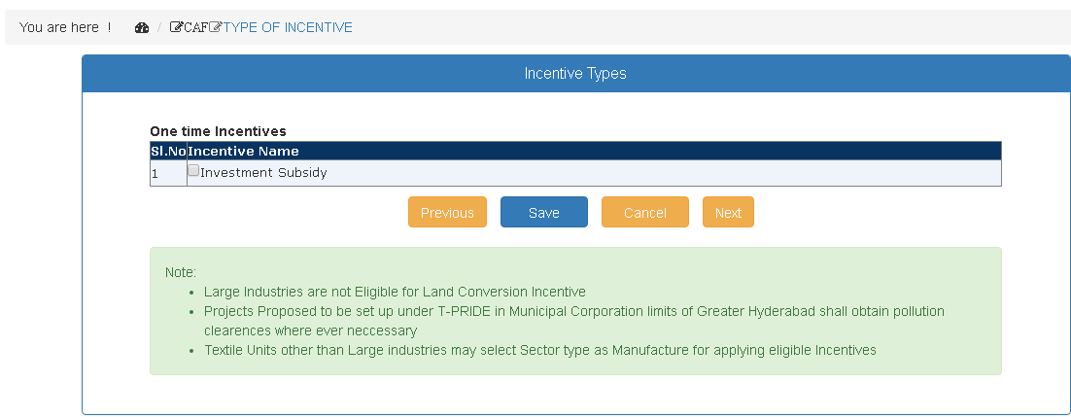
Select the incentive you want to apply for and click on save button for saving the details, once details saved it will ask for click on Next button for moving further.

When you click on Next button below page will be displayed. This page is used to upload the documents which supports to your incentives application.

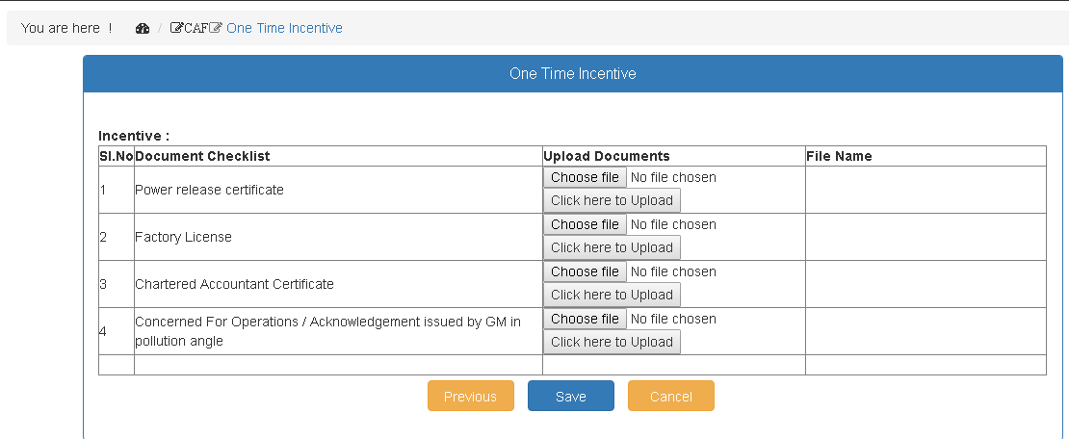
Once above documents uploaded click on Save button, your application will be submitted and below confirmation will be displayed:

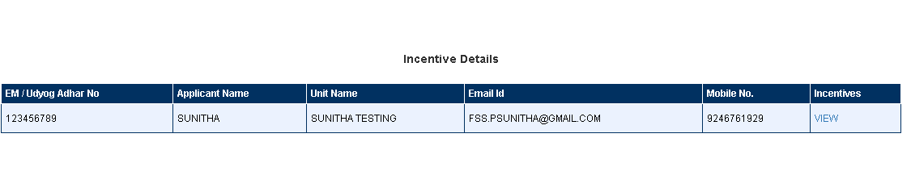
You can click on view option to view the application entered by you. When you click on view option below screen will be displayed. Now Your process for applying for incentives is completed.

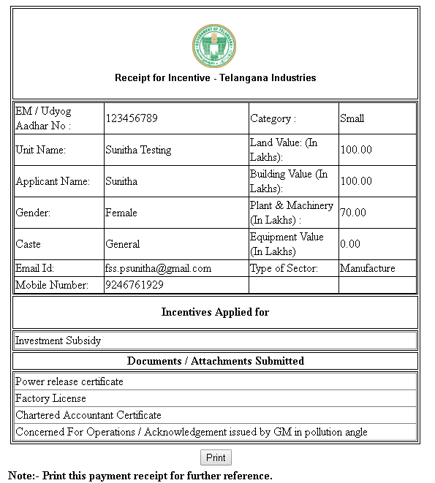

****** Thank You ******

